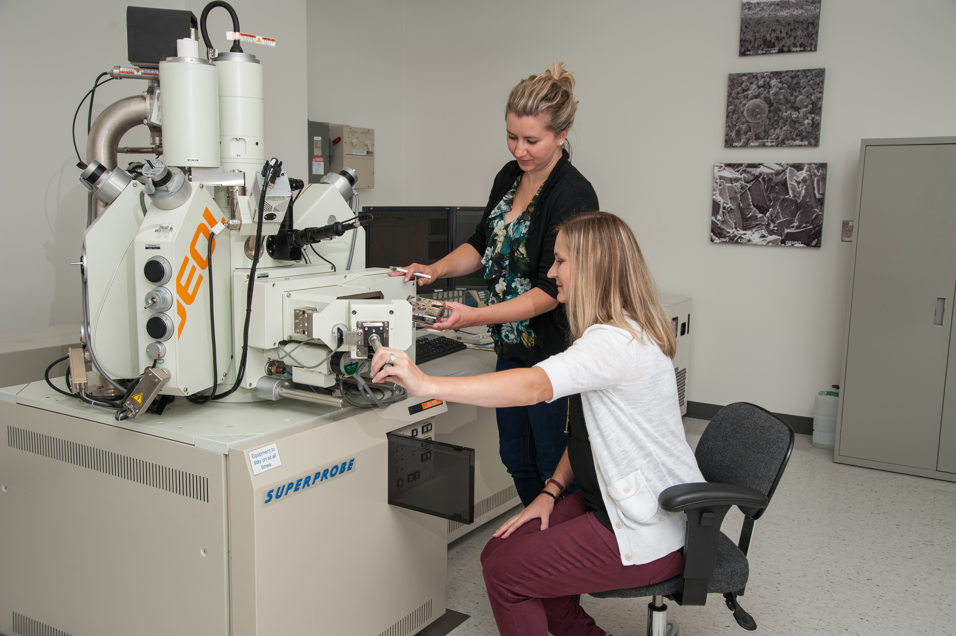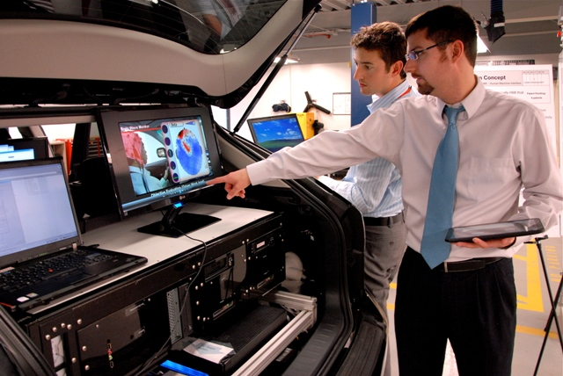

**Open Positions**

DENSO offers co-op and full-time opportunities in Engineering,   
Sales & Marketing, Quality and Business Operations.

Check out these open positions   
and more and apply online today at densocareers.com

|  |
| --- |
| * **Powertrain Engineers**   - Calibration  - Fuel Economy |
| * **Thermal Engineers**   - Engine Cooling  - HVAC  - R&D |
| * **Embedded Software Engineers**   - C++ and C Language  - Simulink/Matlab  - Human Machine Interface |
| * **Entry Level Sales**      * **Automotive Account Managers** |
| * **Co-ops**   - Mechanical Engineering  - Electrical Engineering |

DENSO in North America

* Who is DENSO? We’re one of the world’s largest global suppliers of advanced automotive technology, systems and components
* Customers include all major carmakers worldwide,  
  heavy duty manufacturers and aftermarket
* We have more than 150,000 employees in 38 countries and regions around the world; 24,000 employees in the United States, Canada and Mexico
* Our main business groups include: Powertrain, Thermal, Body Electronics, Driving Control and Safety Systems
* North American Regional Headquarters are located in Southfield, Michigan.
* We have more than 45 engineering and technical   
  centers around the globe
* In North America, we’re leading global development and testing of human machine interface technology
* Every year, we invest approximately 9 percent of   
  consolidated net sales back into research and   
  development
* We hold approximately 30,000 active patents worldwide – more than 8,000 in the United States